Used Car Price Intelligence & Predictive Analytics – Power BI Case Study
1. Project Overview
This project is an end-to-end Business Intelligence and Predictive Analytics solution built in Power BI on top of a used-car dataset.
The final report and dashboard help a user to:
- Explore the used-car market across brands, fuel types, transmissions and age bands
- Understand what drives price differences between vehicles
- Evaluate value for money using custom engineered metrics
- Inspect and interpret a machine-learning price prediction model
- Ask questions in natural language (Q&A) and see AI-driven explanations of price drivers
The project demonstrates the full BI lifecycle: data cleaning → modelling → DAX measures → visual design → ML integration → AI & Q&A → storytelling.
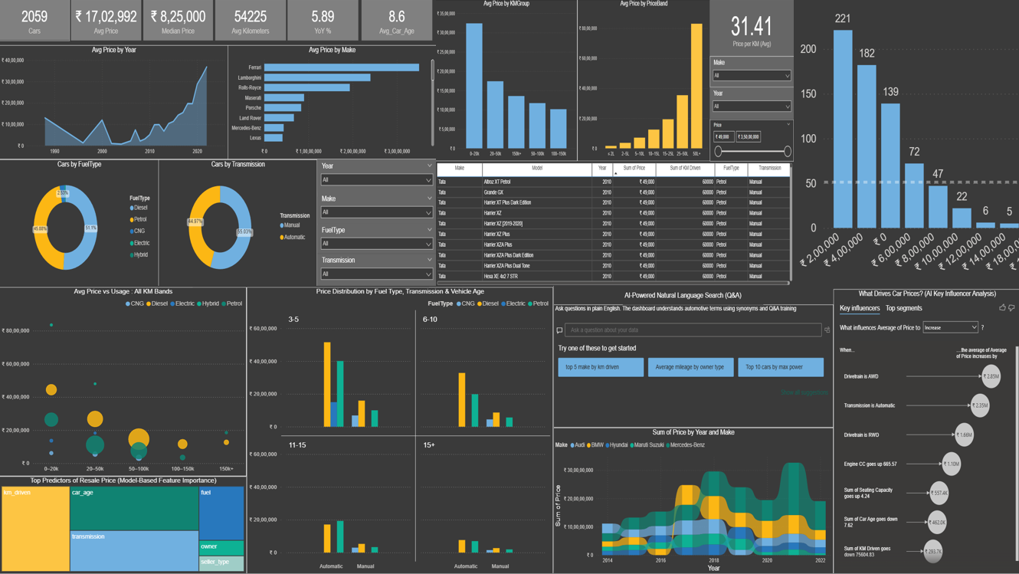

2. Data & Tools
2.1 Datasets
- Car Details v4 (CSV) – core transactional data
  - Make, Model, Year
  - Selling Price
  - KM Driven
  - Car Age
  - Engine CC
  - Fuel Type, Transmission, Drivetrain
  - Seating Capacity, Owner Type and other attributes
- Model Predictions (CSV) – output of a Python machine-learning model
  - Actual_Price, Predicted_Price for each car
- Correlation Matrix (CSV + PNG) – Python-generated correlation matrix used for validation and as a tooltip.
2.2 Technology Stack
- Power BI Desktop – data prep, modelling, DAX, visuals
- Power Query – cleaning, feature engineering, dimension creation
- DAX – metrics for pricing, value, and predictive KPIs
- Python / ML (external) – model training, feature importance, correlation heatmaps
- Power BI AI visuals – Decomposition Tree, Key Influencers, Q&A

3. Data Preparation & Modelling
3.1 Cleaning & Transformation (Power Query)
Key steps:
- Removed duplicates and invalid rows
- Converted all numeric columns to the correct data types
- Extracted numeric value from text fields such as "1197 cc" → 1197 (Engine_CC)
- Imputed missing values:
  - Dimensions like Height/Width/Length → replaced with column mean
  - Seats → replaced missing entries with 4 (standard passenger car)
  - Fuel tank and seating gaps filled based on averages
- Engineered categorical fields:
  - KMGroup (0–20k, 20–50k, 50–100k, 100–150k, 150k+)
  - PriceBand (≤2L, 2–5L, 5–10L, 10–15L, 15–25L, 25L+)
  - Car_Age_Group (0–3, 3–5, 5–10, 10–15, 15+)
Example:

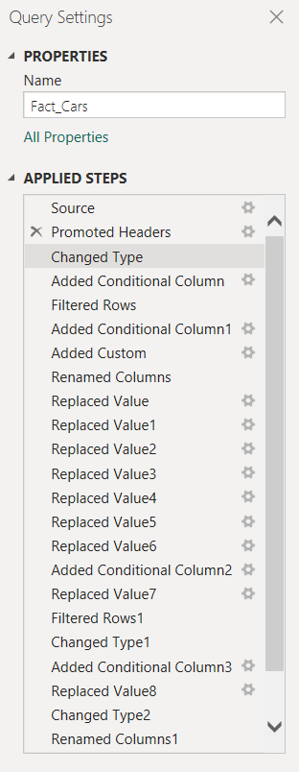

3.2 Dimensional Model
Created a star schema:
- Fact_Cars – all transaction records and engineered fields
- Dimensions:
  - Dim_Fuel
  - Dim_Transmission
  - Dim_MakeModel
  - Dim_Year
  - Dim_KMGroup
  - Dim_PriceBand
To connect ML results to the car records, an Index column was created in both Fact_Cars and model_predictions, enabling a 1–1 relationship.

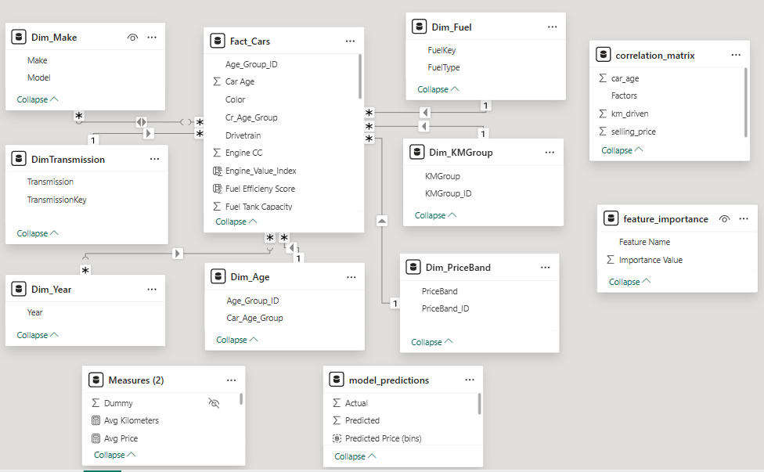

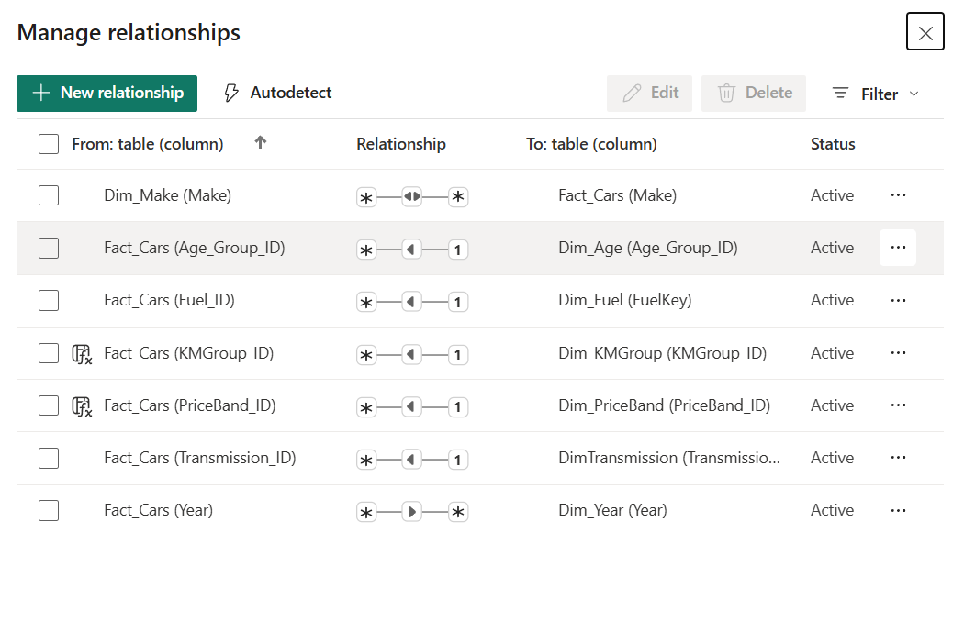

4. Key DAX Measures
A library of DAX measures was created, grouped into four categories.
4.1 Core Price & Volume Metrics
- Cars – total car count
- Avg Price – mean selling price
- Median Price – median selling price
- Avg Kilometers – mean KM Driven
- Avg Vehicle Age – mean age of the vehicles
4.2 Predictive Model Metrics (from model_predictions)
- MP Rows – number of prediction rows
- Predicted / Actual – aggregate prediction vs true price
- MP RMSE – Root Mean Squared Error of predictions
- MP MAPE – Mean Absolute Percentage Error
- MP Accuracy % – model accuracy in percentage
- Prediction Error – average difference between Predicted and Actual
4.3 Value & Efficiency Metrics (Analytics Page)
- Price per KM – KMDriven / (Price in Lakhs)
- Price per Seat – Price / Seats
- Composite Value Score (0–100) – weighted ranking combining the three metrics to identify best-value brands/models – Engine Val
4.4 Supporting Measures
- Price and KM totals by Make, Model, FuelType, Transmission, and age
- YoY change in Avg Price and Volume for time-series visuals
Example:
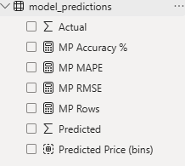
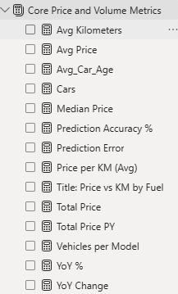
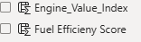
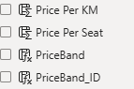

5. Dashboard Pages & Analytical Story
5.1 Page 1 – Market Overview
Goal: Give a compact, high-level picture of the used-car market.
Visuals:
- Cards – Total Cars, Avg Price, Median Price, Avg KM, Avg Vehicle Age
- Line / Area charts – Avg Price by Year, Cars by Year
- Donut charts – FuelType share, Transmission share
- Bar charts – Top Brands by Volume, Cars by Car_Age_Group
Key Insights:
- Petrol and Diesel dominate the fleet; Electric and Hybrid are niche but high-priced.
- Most listed vehicles are between 3–7 years old, aligning with common replacement cycles.
- Premium brands cluster at high prices even for older cars.
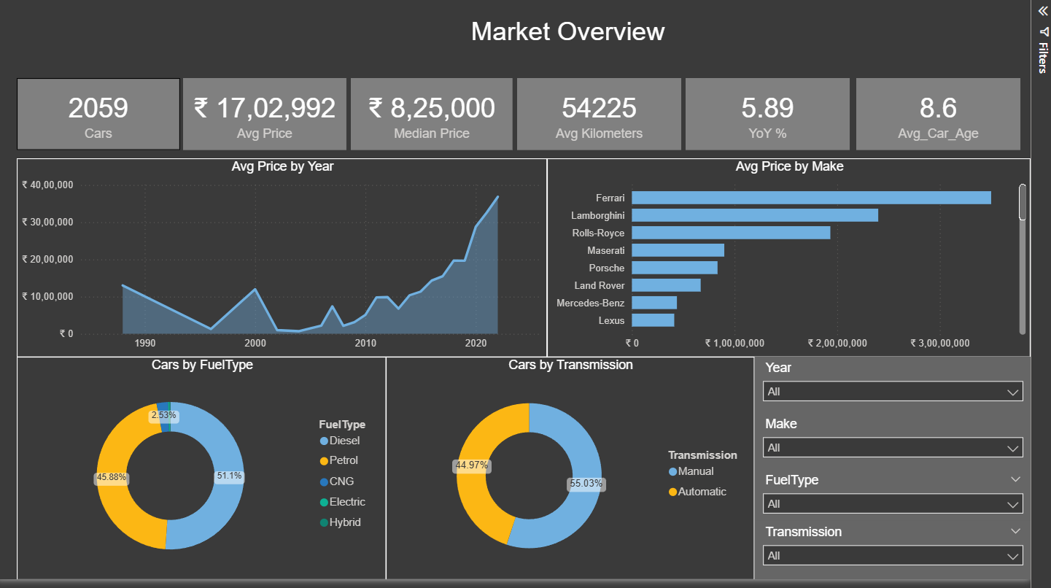

5.2 Page 2 – Buyer Insights & Value Analysis
Goal: Help a buyer or analyst judge how price behaves across usage and price bands.
Visual highlights:
- Column chart – Avg Price by KMGroup
- Column chart – Avg Price by PriceBand
- Interactive table listing Make, Model, Year, Sum of Price, Sum of Kilometers, FuelType, Transmission.
This page acts as a “price lookup” and helps answer questions like:
- “What’s a typical price for a 50–100k KM car?”
- “How much more do higher price band cars cost on average?”
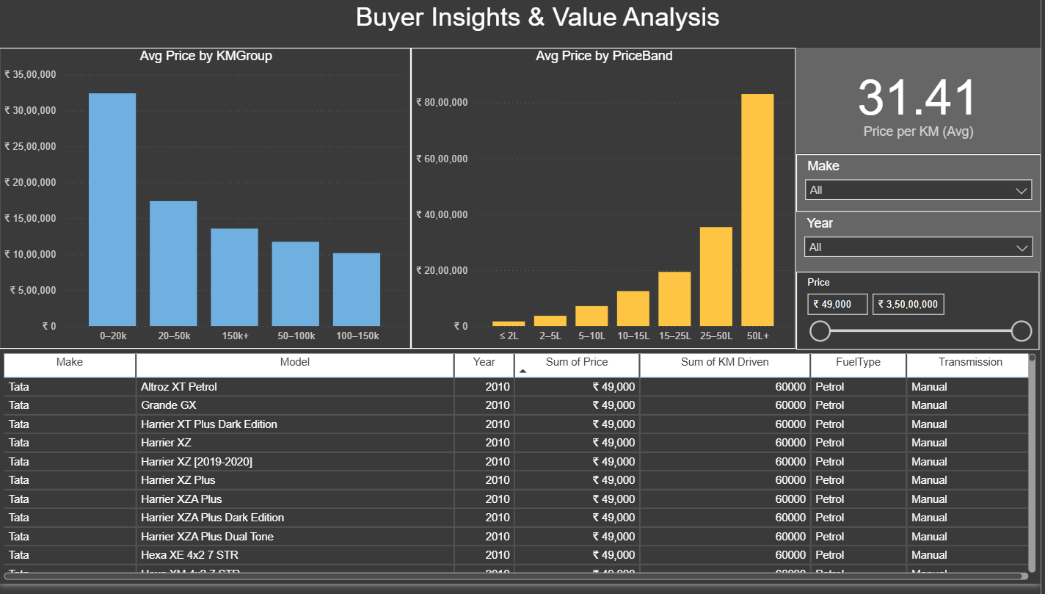

5.3 Page 3 – Market Dynamics & Pricing Drivers
Goal: Explain why prices look the way they do using multivariate and ML-derived insights.
Visuals:
- Bubble chart – Avg Price vs KMGroup by Fuel Type
  - X: KMGroup
  - Y: Avg Price
  - Size: Count of Cars
  - Colour: FuelType
→ Shows how usage and fuel type combine to affect price.
- Small multiples – Avg Price by Car_Age_Group & FuelType
→ Highlights depreciation patterns for each fuel.
- Feature Importance bar chart (from ML model) –
km_driven, car_age, transmission, fuel, seller_type, etc.
Insights:
- Petrol cars dominate mid-usage bands (20–80k KM) at reasonable prices.
- Diesel vehicles show stronger price retention for very high usage.
- Feature importance confirms domain expectations: Car Age and KM Driven are primary price drivers.
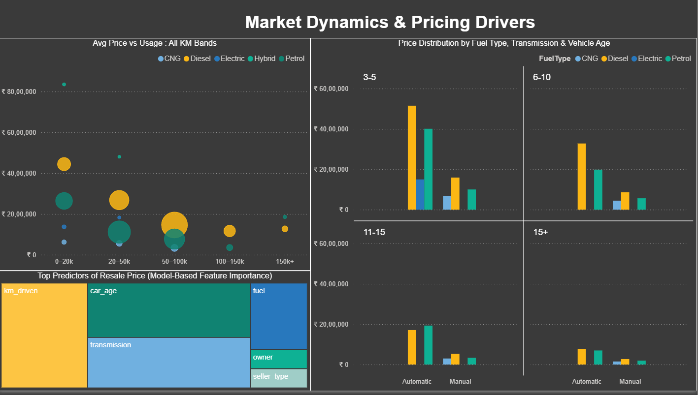

5.4 Page 4 – Predictive Insights (ML Integration)
Goal: Evaluate and explain the behaviour of the machine-learning price prediction model.
Top KPI Cards:
- Prediction Accuracy %
- MAPE %
- RMSE (₹)
- Mean Error (₹)
Correlation Matrix (Python Validation):
- A matrix of selling_price, km_driven, car_age
- Background conditional formatting + tooltip confirms:
  - Negative correlation between Price & Age / KMDriven
  - Positive correlation between KMDriven and Age.
Decomposition Tree – “What drives Predicted Price?”
- Target: Avg Predicted Price
- Explain by: Make → Transmission → FuelType → KMGroup → Car_Age_Group
- Shows how each combination contributes to higher or lower predicted prices and reveals segments where the model forecasts the highest values.
Predicted Price Distribution Histogram
- Binned Predicted into price bands
- Shows where most predictions cluster (₹2–8L) and long-tail segments above ₹15L.
Insights:
- The model performs best for mainstream segments (Petrol/Diesel, 3–7 year age band, 20–80k KM).
- Prediction uncertainty is higher for very old, very high-mileage, or niche fuel types (Electric).
- Price clusters align with real-world budget categories.
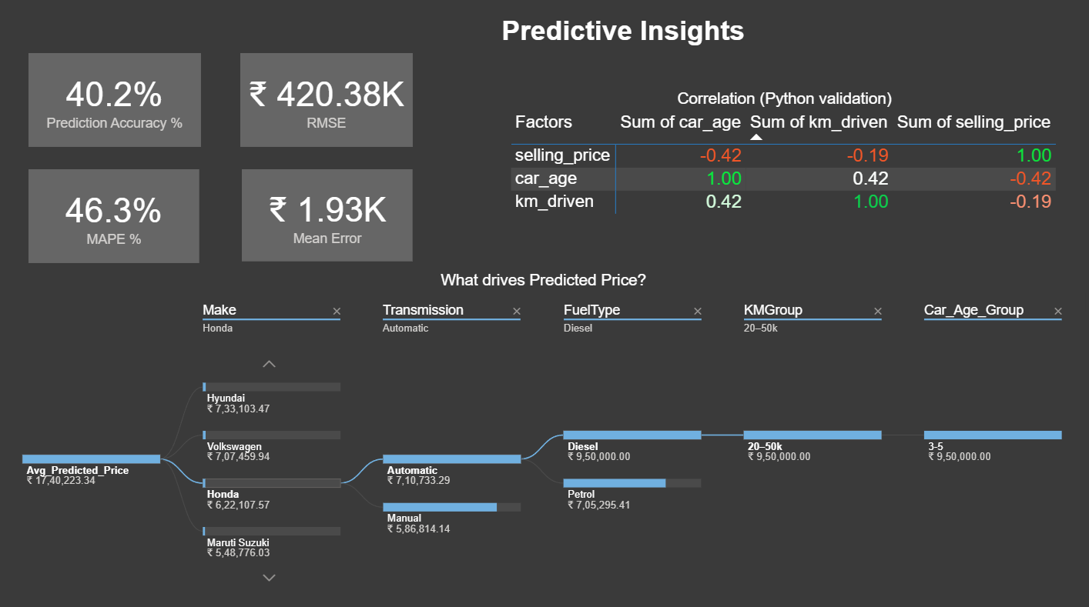

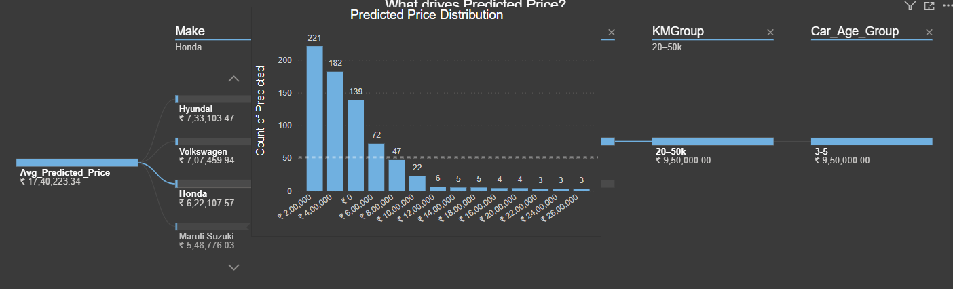

5.5 Page 5 – Smart Insights: Q&A Intelligence and Key Price Drivers

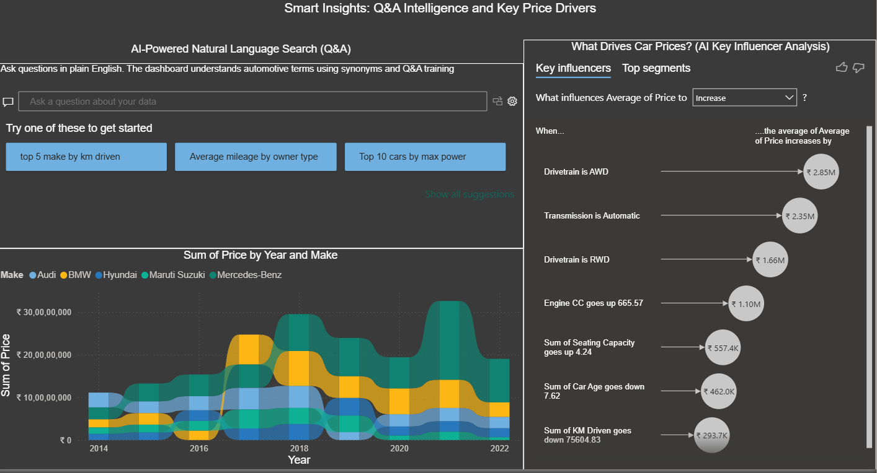

5.5.1 AI-Powered Natural Language Search (Q&A)
I implemented the Power BI Q&A visual so that business users can ask questions in plain English and receive dynamic answers.
To make Q&A behave like a conversational AI layer:
- Renamed and standardised fields (e.g. Price, KM Driven, Engine CC)
- Added synonyms and semantic mappings, such as:
  - brand → Make
  - mileage → KM Driven
  - engine size → Engine CC
- Used “Teach Q&A” to resolve ambiguous phrases and train the model.
- Configured starter prompts such as:
  - “Top 5 makes by KM driven”
  - “Average mileage by owner type”
  - “Top 10 cars by max power”
  - “Which location has the most petrol cars?”
This demonstrates my ability to configure Q&A, design synonyms, and guide users with suggested questions so the visual works like an AI assistant inside the report.
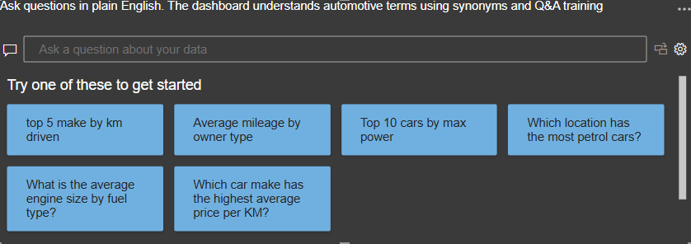

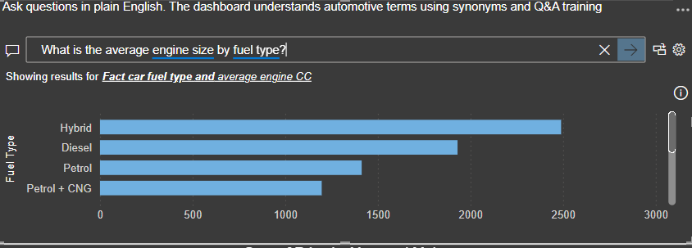

5.5.2 Key Influencer Analysis – “What Drives Car Prices?”
To identify key drivers of pricing, I built a Key Influencers visual using Avg Price as the target.
Steps performed:
- Created a robust Avg Price measure to avoid aggregation issues.
- Selected relevant influencers:
  - Engine CC, Max Power, Torque
  - KM Driven
  - Transmission & Drivetrain
  - Car Age
  - Seating Capacity
  - Fuel Type and Location
- Removed circular features like PriceBand to keep the model meaningful.
- Verified data types and granularity for accurate statistical modelling.
- Enabled slicers (Year, Make, FuelType) so the influencers recompute dynamically.
Key insights from the visual:
- AWD drivetrain and Automatic transmissions significantly increase average price.
- Large-capacity engines (high CC) and higher seating capacity are associated with higher prices.
- High mileage and older vehicles reduce price.
- The Top Segments tab automatically highlights high-value micro-segments, such as newer diesel cars with large engines and low usage.
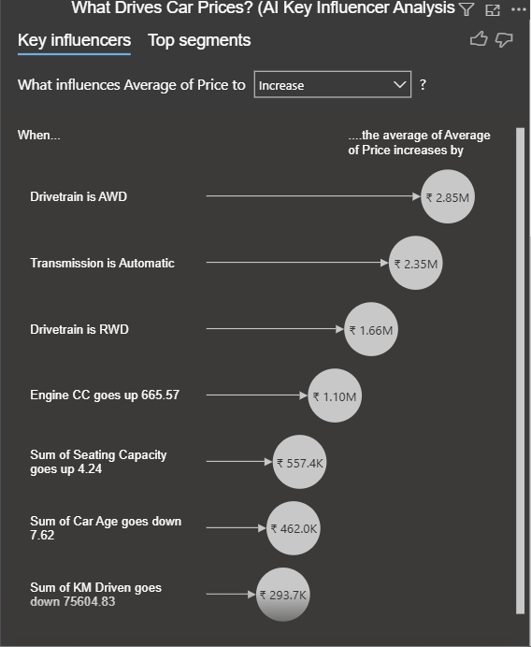
This visual showcases my understanding of ML-style feature influence, segmentation, and automated insight generation within Power BI.

5.5.3 Brand Trend Analysis – Ribbon Chart
To explore how brand ranking shifts over time, I added a Ribbon Chart focused on the top 5 makes.
Configuration:
- Axis: Year
- Values: Avg Price
- Legend: Make (Top N filter set to 5)
- Sorted by Avg Price for correct rank ordering
- Currency formatted to Indian format (₹ Lakhs)
The ribbon chart reveals:
- How premium brands move up or down the price ladder year over year
- When certain makes gain or lose market strength
- The contrast between luxury and mass-market brands over time
This adds a temporal, business narrative on top of the AI-driven analysis.
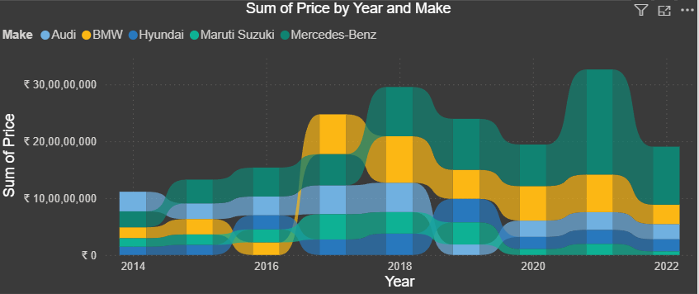

6. Python / ML Integration Summary
Even though the machine-learning model was built outside Power BI, the report integrates it tightly by:
- Importing model_predictions for Predictive KPIs and visuals
- Using feature importance output in a bar chart to explain price drivers
- Embedding a Python correlation heatmap as a tooltip in the Predictive Insights page
This demonstrates my ability to act as a bridge between Data Science and BI, turning models into consumable analytics.
7. Overall Business & Technical Impact
Business Impact
- Helps a buyer or dealer benchmark prices by age, usage, fuel, and brand
- Highlights high-value models using custom value metrics
- Reveals the true drivers of price using Key Influencers and feature importance
- Evaluates and explains the performance of a predictive pricing model
- Enables non-technical users to ask questions in natural language and receive answers instantly
Technical Skills Demonstrated
- Power Query transformation and dimensional modelling
- Building a star schema and 1–1 relationships with external ML output
- Advanced DAX for KPIs, value indices, and composite scoring
- Use of AI visuals – Decomposition Tree, Key Influencers, Q&A
- Drill-through navigation and tooltips with custom images (Python heatmap)
- Visual design tailored to business personas (buyers, analysts, management)

Conclusion
This project successfully delivers a comprehensive, AI-enhanced analytical solution for understanding and predicting used-car prices. Starting from raw, inconsistent data, the report builds a fully structured star-schema model, derives meaningful DAX-based KPIs, and integrates a machine-learning prediction layer to provide deeper, data-driven insights.
Through advanced analytical visuals—including Key Influencers, Decomposition Trees, Ribbon Charts, Smart Q&A, and Value Score metrics—the dashboard translates complex automotive patterns into intuitive, decision-ready insights. Business users can quickly explore what drives price, how brands trend over time, which models offer best value, and where the ML model performs well or poorly.
By combining traditional BI, advanced analytics, and AI-powered natural language interaction, the solution demonstrates the capability to move beyond static reporting into intelligent, automated decision support. The dashboard is practical for dealerships, buyers, analysts, and pricing strategists, while showcasing strong technical expertise across Power BI, DAX, modelling, ML integration, and UX design.
Overall, this project reflects a complete end-to-end analytical lifecycle—data preparation, modelling, insight generation, predictive analysis, and AI augmentation—positioning it as a high-impact portfolio artifact for analytics, BI, and data science roles.

